Project Development Phase
Model Performance Test

Date | 08 October 2026
Team ID | 9100Byte
Project Name | Implement Client Script & UI Policy (Incident)
Maximum Marks | As per evaluation

Model Performance Testing:
Project team shall fill the following information in model performance testing template.
S.No. | Parameter | Values | Screenshot
1. | Configuration Summary | ServiceNow Incident configuration using one UI Policy and three Client Scripts. The UI Policy controls Assignment group and Urgency based on Impact. | 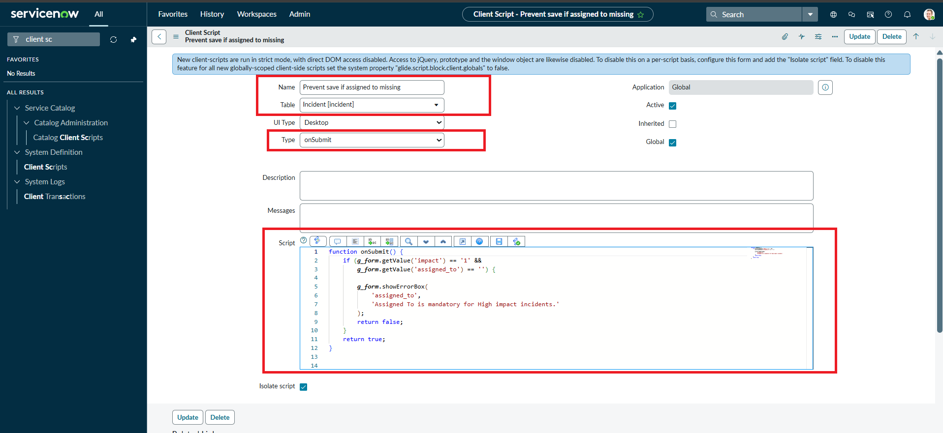
2. | Functional Accuracy | High Impact makes Assignment group mandatory and Urgency read-only; onChange sets Urgency High; onSubmit blocks missing Assigned To; onCellEdit blocks direct State changes. | 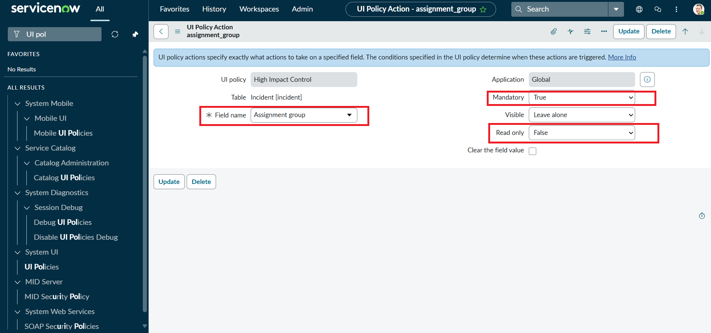
3. | Conditional Rule Execution | Rules execute only under their defined conditions and restore normal behavior when the condition becomes false. | 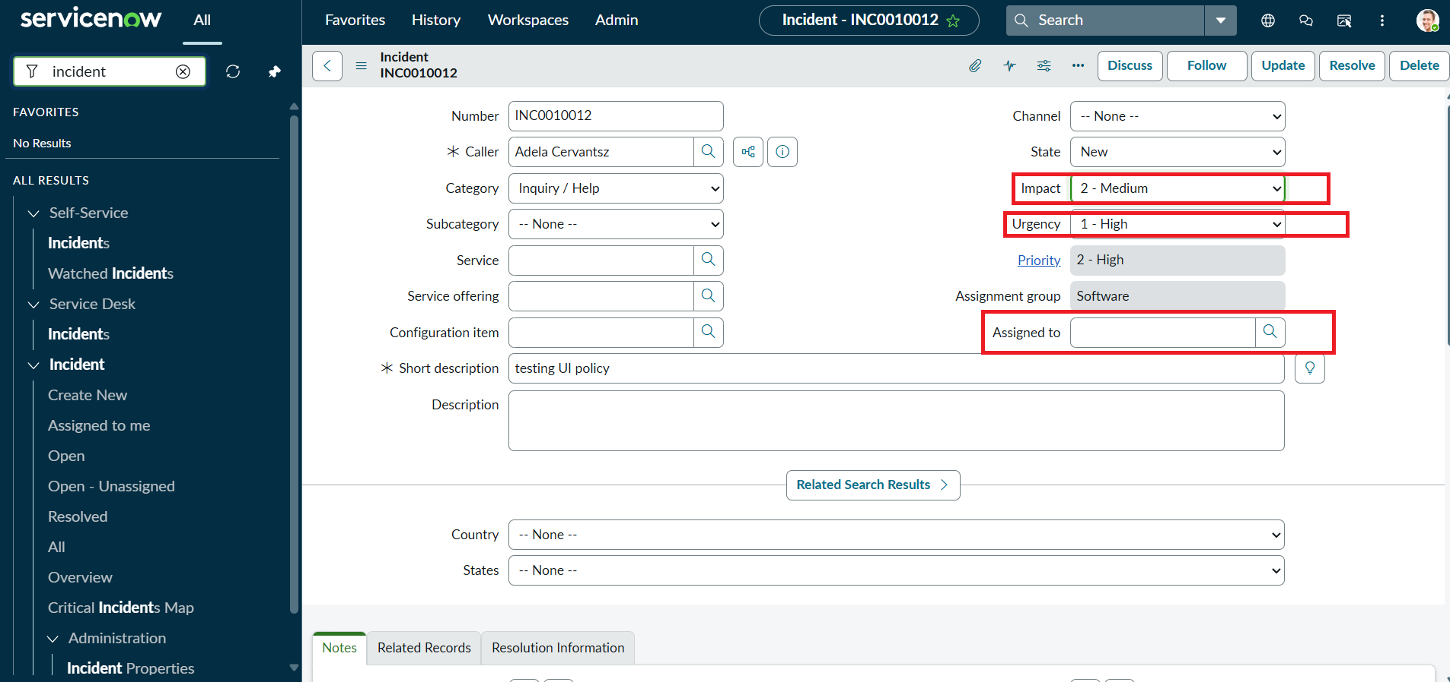

Execution Result Summary
Overall Result: PASS – implementation behavior is evidenced by the supplied ServiceNow screenshots and project document.
UAT Result: PASS – all listed functional scenarios are documented as successfully configured/verified.
Defects: None identified in the supplied evidence.
Evidence Status: Existing screenshots from the submitted implementation document have been retained and reused.
Project: Implement Client Script & UI Policy (Incident) | Team: 9100Byte | Date: 08 October 2026
Configuration and Validation Evidence
Evidence: Supplied ServiceNow implementation screenshot(s).
image7.png
image3.png
image12.png

